# NAAN MUDHALVAN PROJECT TITLE:

# Sustainable Smart City Assistant Using IBM Granite LLM Generative AI with IBM

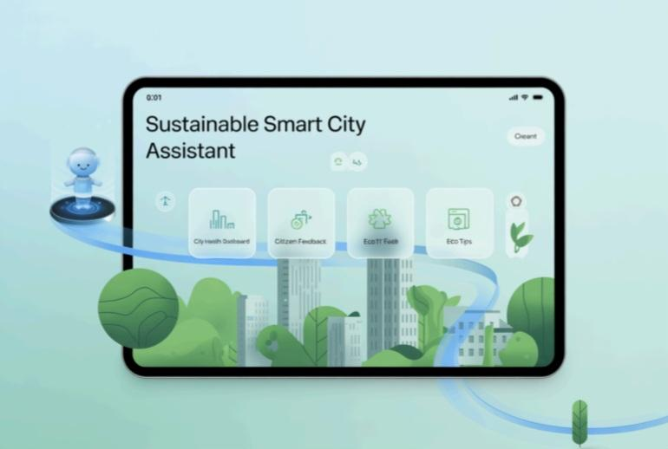

TEAM MEMBERS:

* KAVIPRIYA.M
* KANMANI.V
* MALLIKA.T
* MALARVIZHI.S

PROJECT OVERVIEW:

This project leverages IBM Granite models (via Hugging Face) to build a Sustainable Smart City Assistant that supports:

City sustainability monitoring,Governance insights,Citizen engagement through feedback tools,Quick utilities such as,City Health Dashboard,Document summarization,Citizen feedback processing,Eco-friendly tip.The projects deployed on Google Colab for easy setup, GPU acceleration, and smooth performance.

PRE REQUISITES:

1.Gradio Framework Knowledge

2. IBM Granite Models (Hugging Face)

3. Python Programming Proficiency

4. Version Control with Git

5. Google Colab T4 GPU Knowledge

PROJECT WORKFLOW:

Activity-1: Exploring Naan Mudhalavan Smart Interz Portal.

Activity-2: Choosing a IBM Granite Model From Hugging Face.

Activity-3: Running Application In Google Colab.

Activity-4: Upload your Project in Github.

Choose a IBM Granite model From Hugging Face.

● Search for “Hugging face” in any browser.

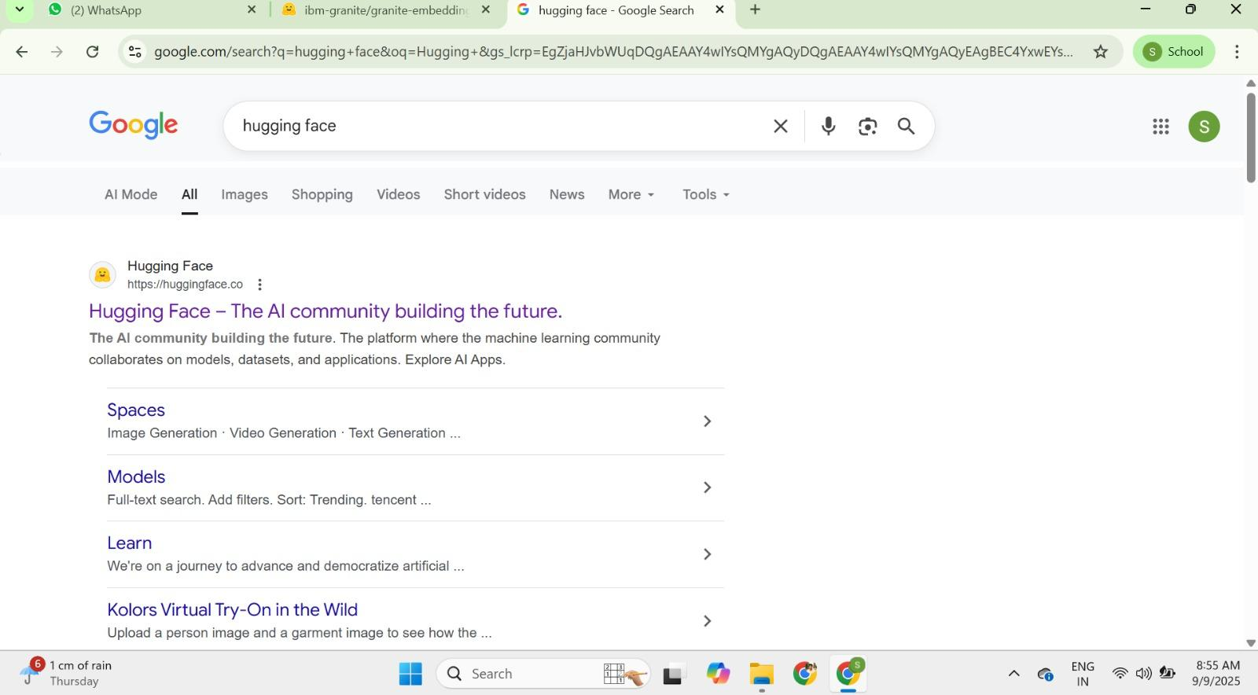

● Then click on the first link (Hugging Face), then click on signup and create Your own account in Hugging Face. Then search for “IBM-Granite models” And choose any model.

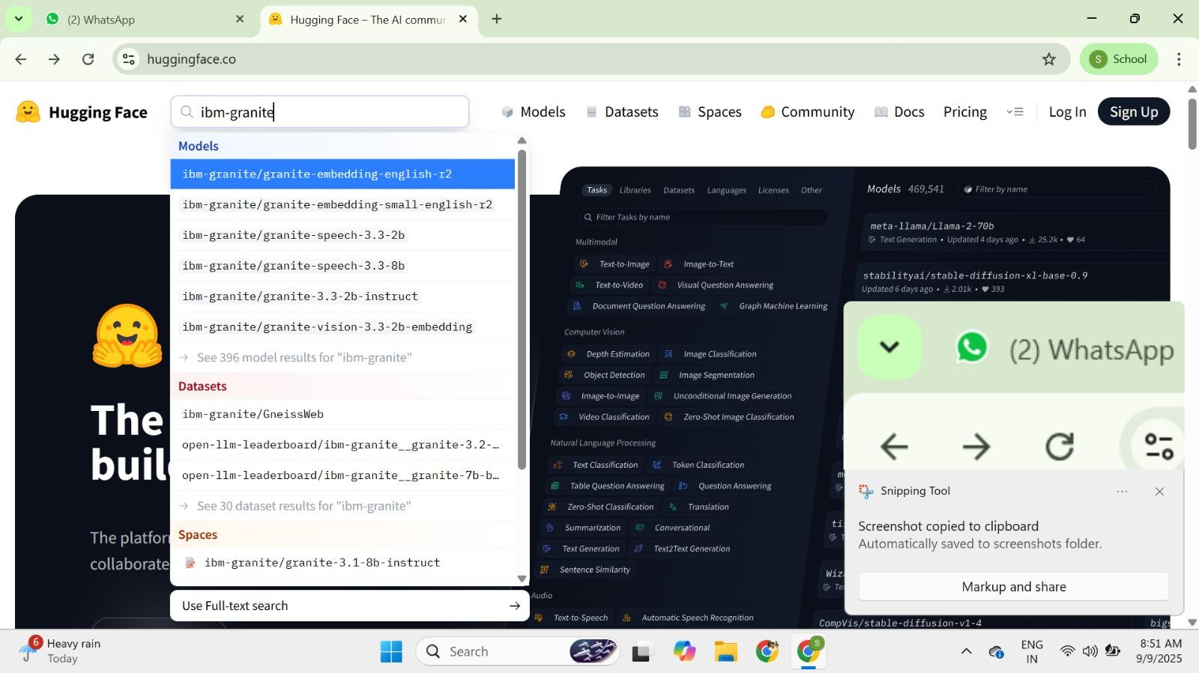

● Here for this project we are using “granite-3.2-2b-instruct” which is Compatible fast and light weight.

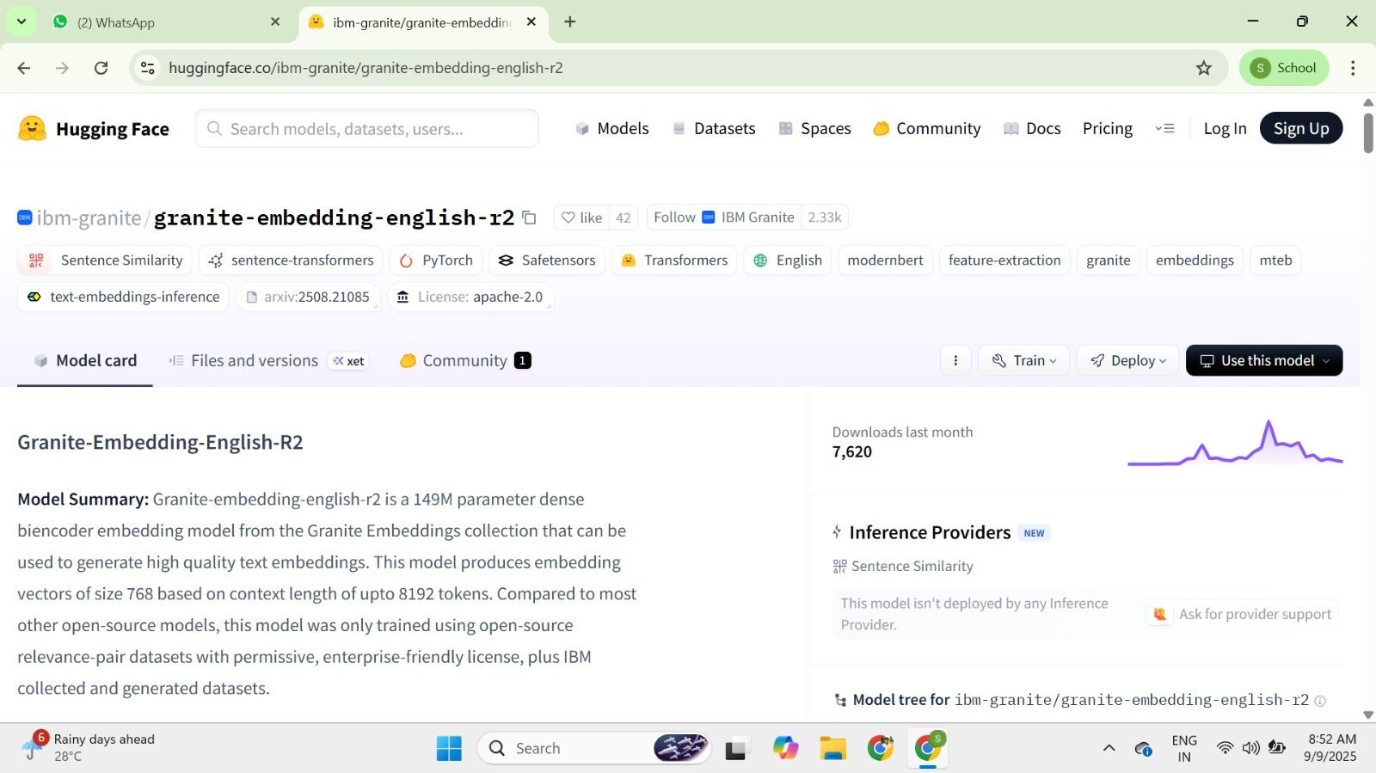

● Change the title of the notebook “Untitled” to “Health AI”. Then click on “Runtime”, then go to “Change Runtime Type”.

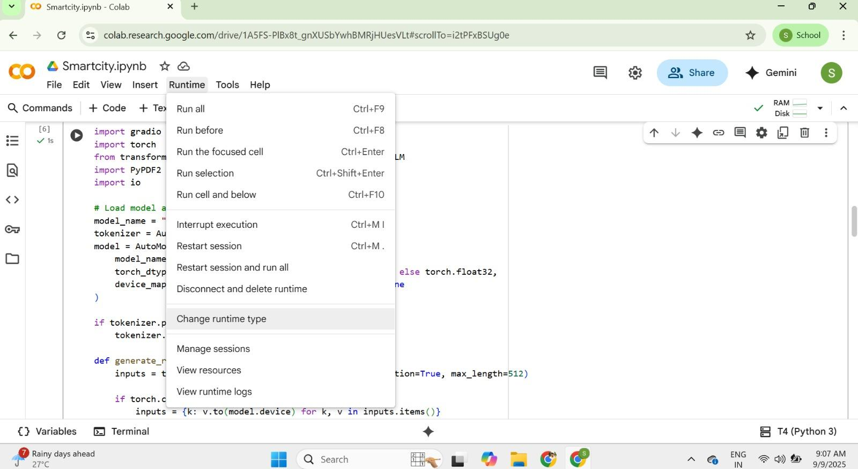

● Choose “T4 GPU” and click on “Save”

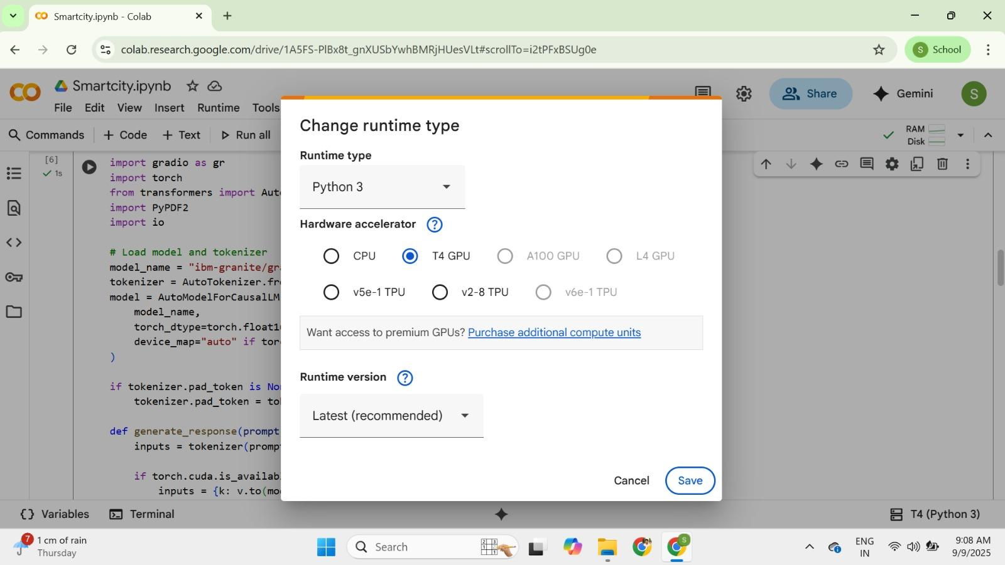

● Then run this command in the first cell “!pip install transformers torch Gradio PyPDF2 -q”. To install the required libraries to run our application.



● Then run the rest of the code in the next cell.

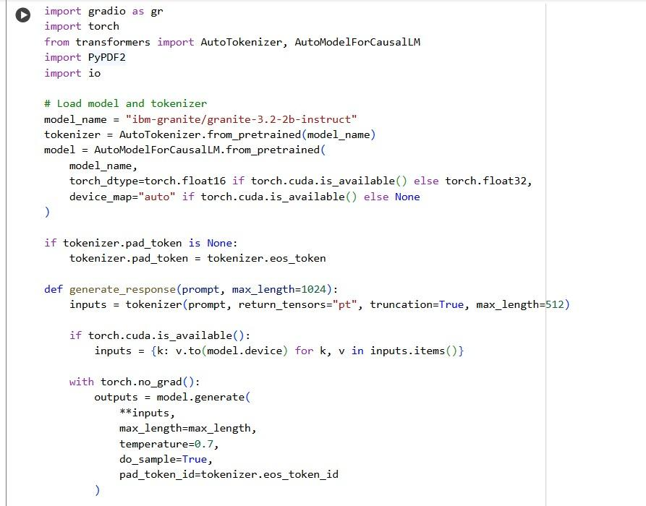

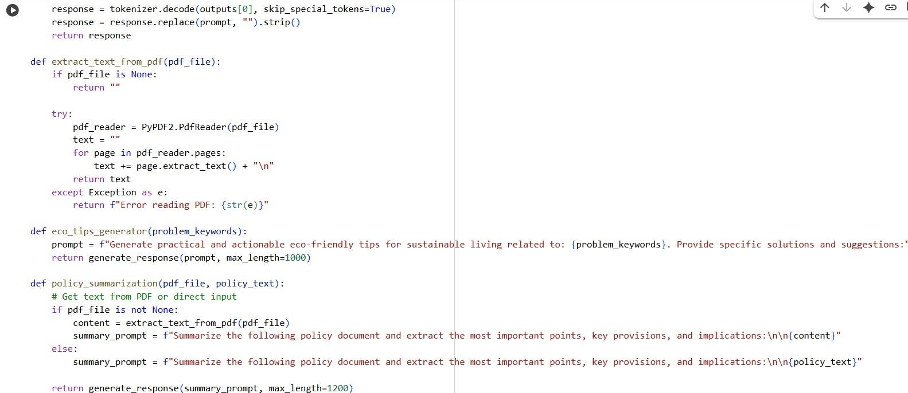

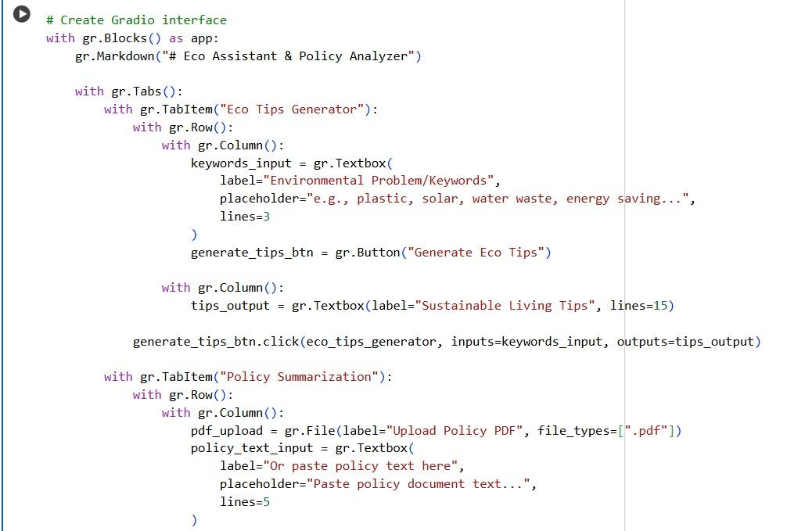

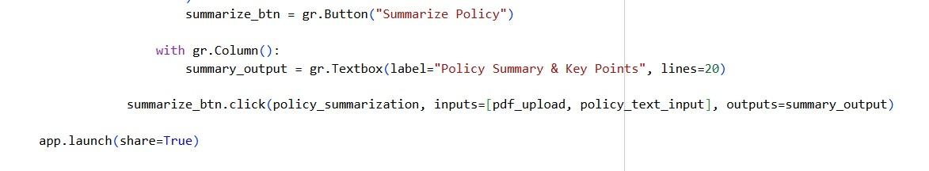

● You can find the code here in this link: Sustainable Smart City Assistant

**OUTPUT:**

● Now you can see our model is being Downloaded and application is Running

● Click on the URl to open the Gradio Application click on the link

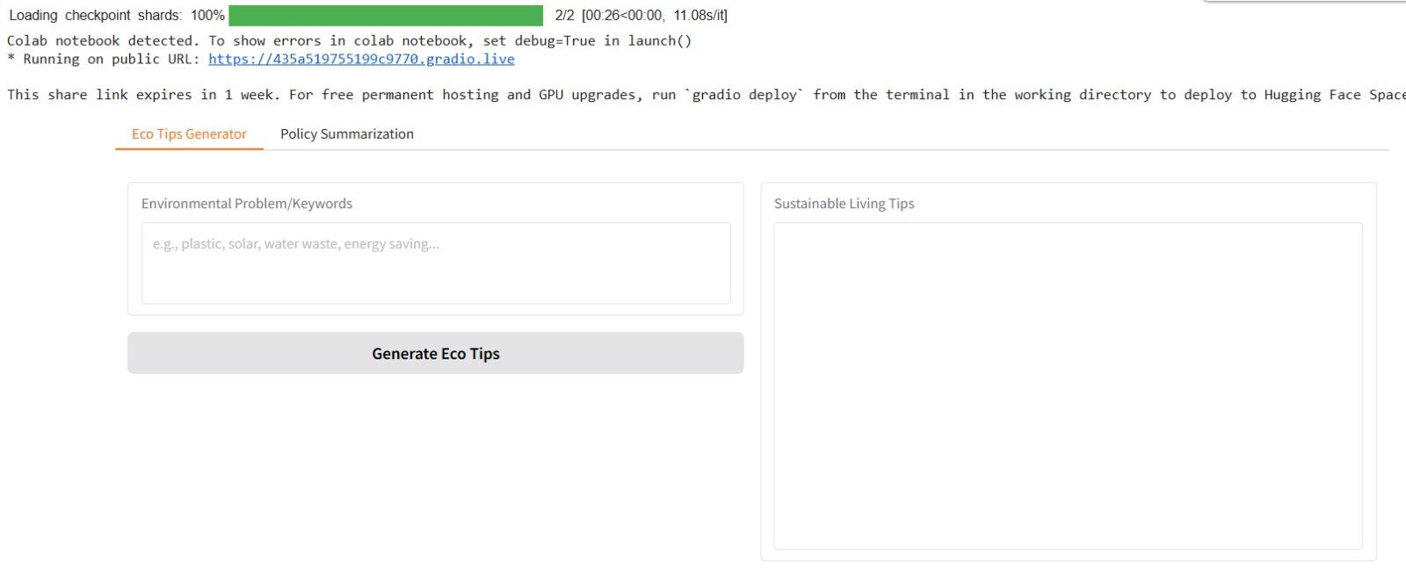

● You can View the Application is the running in the other tab